Kohli Properties – Directions to Office
Office Address: 3 Redlands Terrace Lane (off Julian Avenue), Glasgow, G12 0RW
Our Office entrance is at the rear of the property, off Julian Avenue and down Redlands Terrace Lane
If you Google our postcode, it will send you to the front door of 3 Redlands Terrace. Please DO NOT come to the front door, as it is a house, and you cannot gain access here.

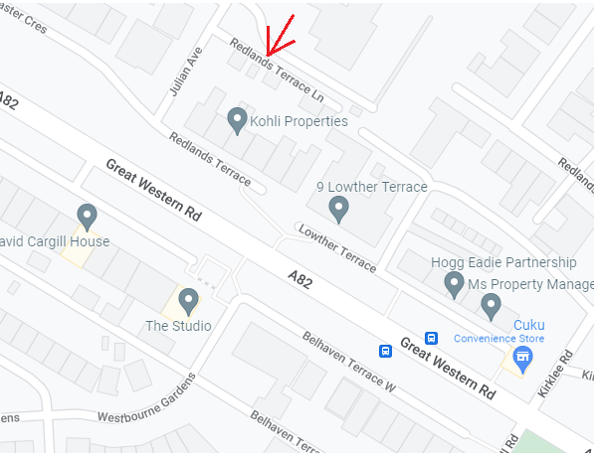
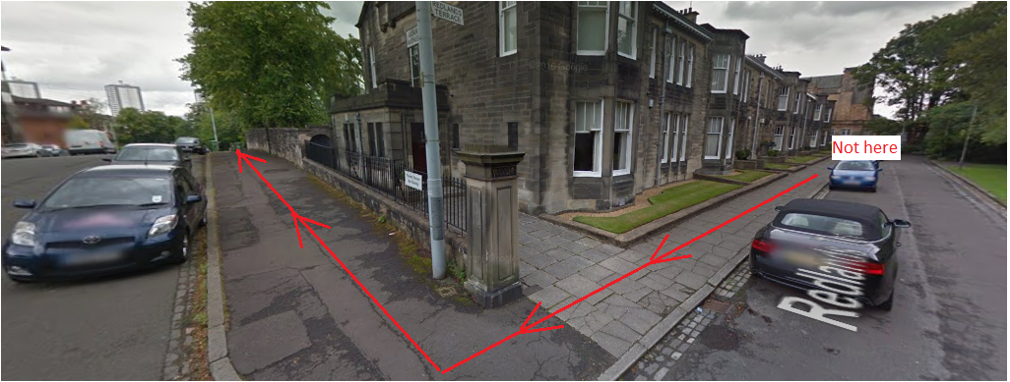
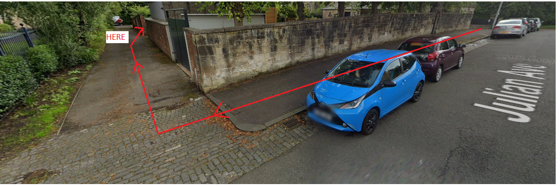
If you are driving, please do not park in Redlands Terrace Lane as this is an access for 6 properties. There is parking available on Julian Avenue.

Office Hours: 9.30am – 5pm (closed from 12.30pm-1.30pm daily for lunch)
Tel: 0141 334 8013 Email: enquiries@kohli-properties.com

